Global Infant Mortality Rate Project
Chibuike Okeke
CCBC
05/05/2019

Global Infant Mortality Rate Project
QUESTION 1:
Descriptive Statistic for the Infant Mortality Rate for Each Region
A). Descriptive Statistic for Africa Region
- Mean: 77.61
- Median: 74.70
- Variance: 607.07
- Standard deviation: 24.64
- Summary table:
Table 1: Summary Statistic for the Infant Rate of Africa Region
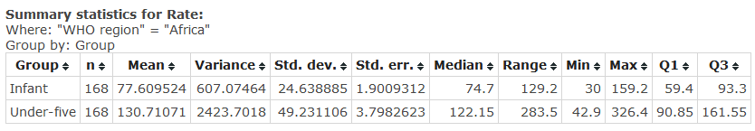
B). Descriptive Statistic for Americas Region
- Mean: 47.47
- Median: 42.10
- Variance: 521.98
- Standard deviation: 22.85
- Summary table:
Table 1: Summary Statistic for the Infant Rate of Americas Region
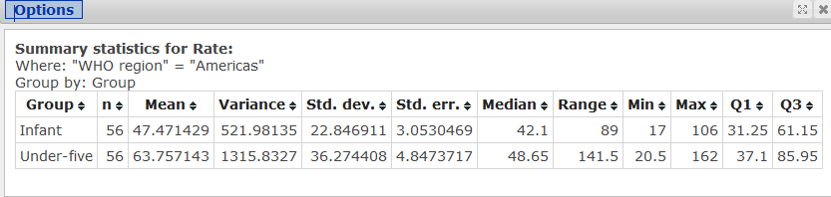
C). Descriptive Statistic for Eastern Mediterranean Region
- Mean: 43.42
- Median: 35.70
- Variance: 512.98
- Standard deviation: 22.65
- Summary table:
Table 1: Summary Statistic for the Infant Rate for the Eastern Mediterranean Region
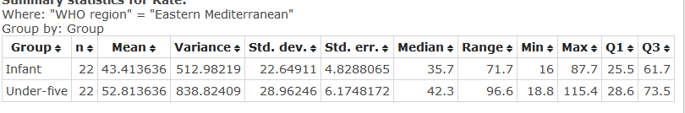
D). Descriptive Statistic for Europe Region
- Mean: 39.48
- Median: 40.05
- Variance: 307.89
- Standard deviation: 17.55
- Summary table:
Table 1: Summary Statistic for the Infant Rate for Europe Region
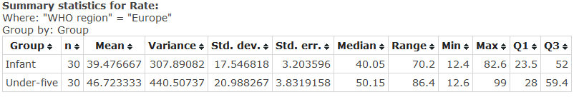
E). Descriptive Statistic for South-East Asia Region
- Mean: 56.88
- Median: 53.55
- Variance: 416.83
- Standard deviation: 20.42
- Summary table:
Table 1: Summary Statistic for the Infant Rate South-East Asia Region
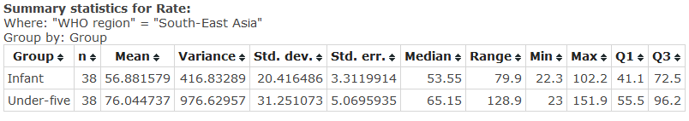
F). Descriptive Statistic for Western Pacific Region
- Mean: 42.83
- Median: 35.65
- Variance: 606.75
- Standard deviation: 24.63
- Summary table:
Table 1: Summary Statistic for the Infant Rate of Africa Region
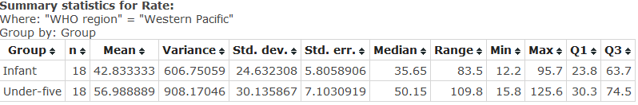
QUESTION 2:
Descriptive Statistic for the Under-five Rate for each Region
- Descriptive Statistic for Under-five in the Africa Region
- Mean: 130.71
- Median: 122.15
- Variance: 2423.70
- Standard deviation: 49.23
- Summary table:
B). Descriptive Statistic for Americas Region
- Mean: 63.76
- Median: 48.65
- Variance: 1315.83
- Standard deviation: 36.27
- Summary table:
C). Descriptive Statistic for Eastern Mediterranean Region
- Mean: 52.81
- Median: 42.30
- Variance: 838.82
- Standard deviation: 28.96
- Summary table:
D). Descriptive Statistic for Europe Region
- Mean: 46.72
- Median: 50.15
- Variance: 440.51
- Standard deviation: 20.99
- Summary table:
E). Descriptive Statistic for South-East Asia Region
- Mean: 76.04
- Median: 65.15
- Variance: 976.63
- Standard deviation: 31.25
- Summary table:
F). Descriptive Statistic for Western Pacific Region
- Mean: 56.99
- Median: 50.15
- Variance: 908.17
- Standard deviation: 30.14
- Summary table:

QUESTION 3:
Constructing Box Plot for Infant Rate and Region
Figure 1: Boxplot for Infant Rate across the WHO Regions
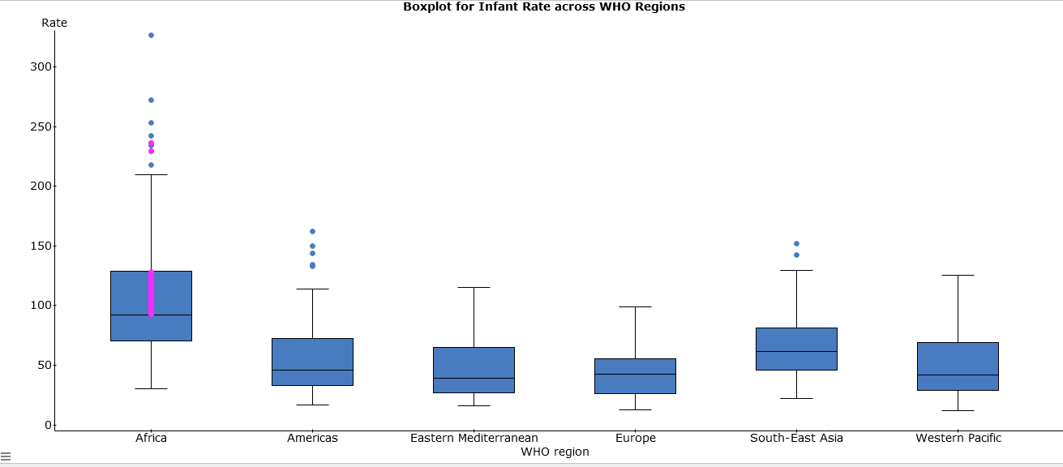
Figure 1 above reveals that the rate of infant mortality is high in Africa with a median rate of 92.3/1000 and the South-East Asia, which record a rate of 61.5/1000. Other regions that recorded the lowest infant rate include Europe, Eastern Mediterranean, and America with a median rate of 38.9/1000, 38.9/1000, and 46.1/1000 respectively.
QUESTION 4:
Confidence Interval for Infant Mortality
Figure 2 reveals the t-stat outcomes
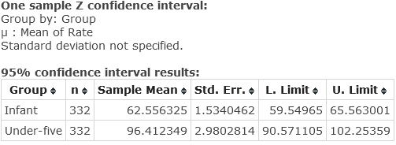
C.1= Mean point estimate ± Margin Error
Where, Margin Error = Zscore * standard error
Standard error= standard deviation÷√sample size
C.1 = 62.56 ± 1.96*1.53
C.1= 59.55≤ N≥65.56
C.1 = (65.56, 59.55)
Therefore, the confidence interval (65.56, 59.55) indicates that the researcher is 95% confidence that the average infant mortality rate is between 59.6/1000 and 65.6/1000 across the six WHO Regions.
QUESTION 5:
Confidence Interval for Under-five Mortality
Using the outcomes of figure 2 above,
C.1= Mean point estimate ± Margin Error
Where, Margin Error = Zscore * standard error
Standard error= standard deviation÷√sample size
C.1 = 96.41 ± 1.96*2.98
C.1= 90.57≤ N≥102.25
C.1 = (90.57, 102.25)
Therefore, the confidence interval (90.57, 102.25) indicates that the researcher is 95% confidence that the under-five mortality rate is between 90.6/1000 and 102.3/1000 across the six WHO Regions
Question 6:
Test of African Ave. Infant Mortality Rate
Given, mean (X)= 77.609, hypothesized mean (µ)=62.56, standard deviation (σ)= 27.97, and the Sample size (n) = 168, test for the hypothesis follows the following steps
Step 1: state the hypothesis
H_{o}: µ=62.56
H₁: µ≠62.56
Step 2: test statistic
Z$=\frac{X-μ}{δ÷√n}$
Z= (77.609 - 62.56)/ (27.97/√168
Z=15.049/2.1579
Z=6.9738
Step 3: Decision Rule
Is that to reject the Null Hypothesis when the P-value is less than the significance level (ά)
Step 4: Make statistical decision
Given the Z-test score of 6.97381, the value of p: 2P (Z>/Z/) is 0.0000566
Now, we compare the p-value with the alpha of 0.05
Step 5: Make conclusion
We do reject the Null Hypothesis in favor of the Alternative Hypothesis because the p-value (0.0000566) is significant enough at p<0.05. Therefore, we can conclude that the African average infant mortality is different (NOT EQUAL TO) from 62.56/1000 born
QUESTION 7:
Describe the Lesson Learned
The outcomes of the T-Statistic above provide a quantitative result of the differences in the global infant mortality rate and under-five mortality rate. Specifically, it can be concluded that at 95% the average infant mortality rate is lesser than the under-five mortality. The lowest average infant mortality is 59.6/1000, which is smaller than the 90.6/1000 recorded in under-five mortality. Conversely, the upper-bound average infant mortality is 65.6/1000 across the globe compared to the 102.3/1000 for the under-five mortality.
Question 8
Recommendations to Improve the Infant and Under-five Mortality
- Increased funding for the innovative finances (Every Woman Every Child, 2015)
- Political support to actualize the fourth, fifth, and sixth UN’s Sustainable Development Goals (SDGs), which focuses on the reducing infant mortality and improving the maternal health by saving the lives of women and children (Every Woman Every Child, 2015)
- Increased focus on priority areas of adolescent and newborn health, food and nutrition, as well as water and sanitation initiatives ensure the ability of girls and women to live long as well as productive life (Every Woman Every Child, 2015). Equally, more attention should be channeled on the conflict zones and nations to safeguard the lifespan of women as well as children (ibid).

Reference
Every Woman Every Child. (2015, May 15). Global strategy for women’s and children health progress report [Video File]. Retrieved from www.youtube.com/watch?v=XAXtLDa6jDE#t=165 (ACCESSED ON May 10, 2019)

